For Current Raa Middle School students…

Scheduling for the 2022-2023 will have online and paper-based components. Teachers will make core course recommendations (*English/Language Arts, math, science, and social studies)*for each student online. Please see the Course Recommendation Guide for detailed information for these core recommendations. Parents and students can view this in FOCUS starting May 9th by following the steps below.

Students will receive their 22-23 Elective Request form in their World History (6th graders) or science (7th graders) class on April 11th.11th. They will return these forms to these same teachers by Friday, April 15th. Please see Raa Arts Course Descriptions to assist with this process. Mrs. Van Camp will then visit every 7th grade science class and every 6th grade World History class to enter their elective requests directly into Focus.

**Special Note Regarding Core Course Recommendations:**Any student or parent who has a question about the Core Course Recommendation should first consult the Course Recommendation Guide for detailed information about course requirements. Questions should then be emailed to the teacher making the course recommendation (i.e., your student’s current teacher) and cc Mrs. Van Camp, the Raa Assistant Principal for Curriculum. The recommendation will be explained and any necessary further steps will be completed at that time.

**Special Note for High School Credit and Advanced Courses:**Placement in honors and high school credit courses require students to meet specific criteria. This is to ensure success throughout the school year in meeting the rigorous course demands. Please see the Course Recommendation Guide for these criteria. These courses follow class-size mandates so strict adherence to course requirements are followed.

**Please follow these steps to view Core Course Recommendations in FOCUS:**

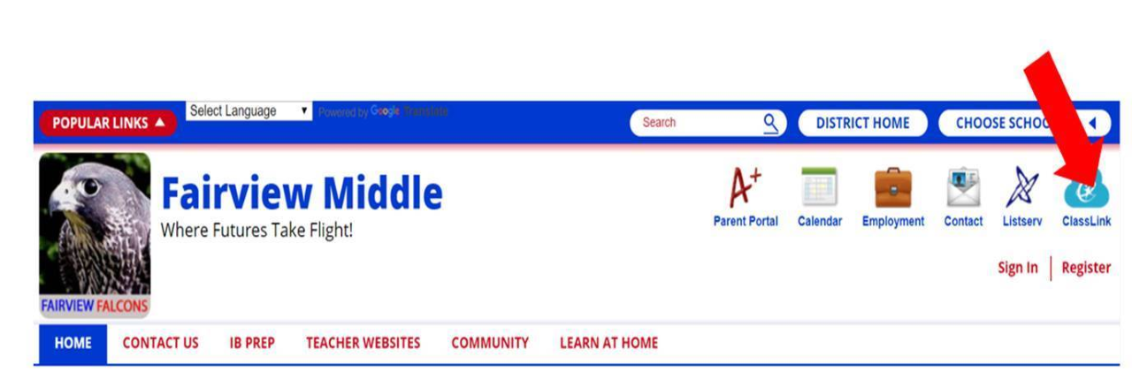

Step 1: Students can login to their FOCUS Student Portal Account through Classlink. Start on our school website.

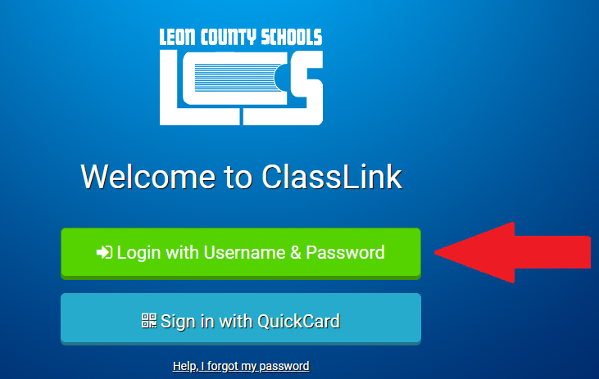

Step 2: Enter your username ([student#@edu.leonschools.net](mailto:student#@edu.leonschools.net)) and your password. If you need your password reset, contact Ms. Payne at [paynem@leonschools.net](mailto:paynem@leonschools.net). Include the student name, student i.d., and student birthdate in the email.



Step 3: Find your FOCUS tile.

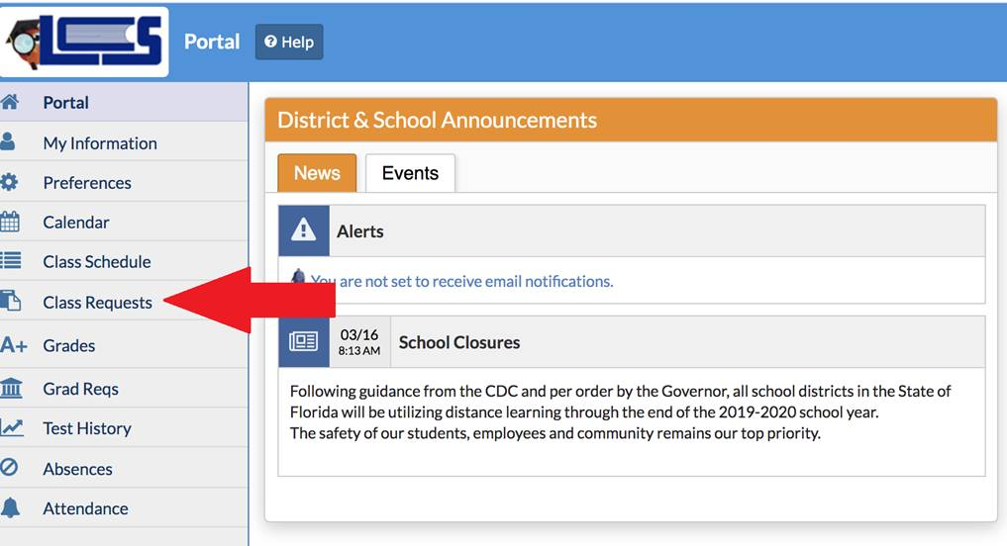

Step 4: On your FOCUS home screen, go to Class Requests.

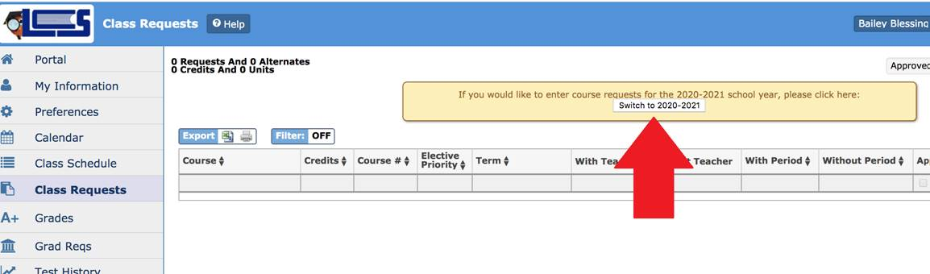

Step 5:  Click the button to switch to the 2022-2023 school year in the top middle of the screen

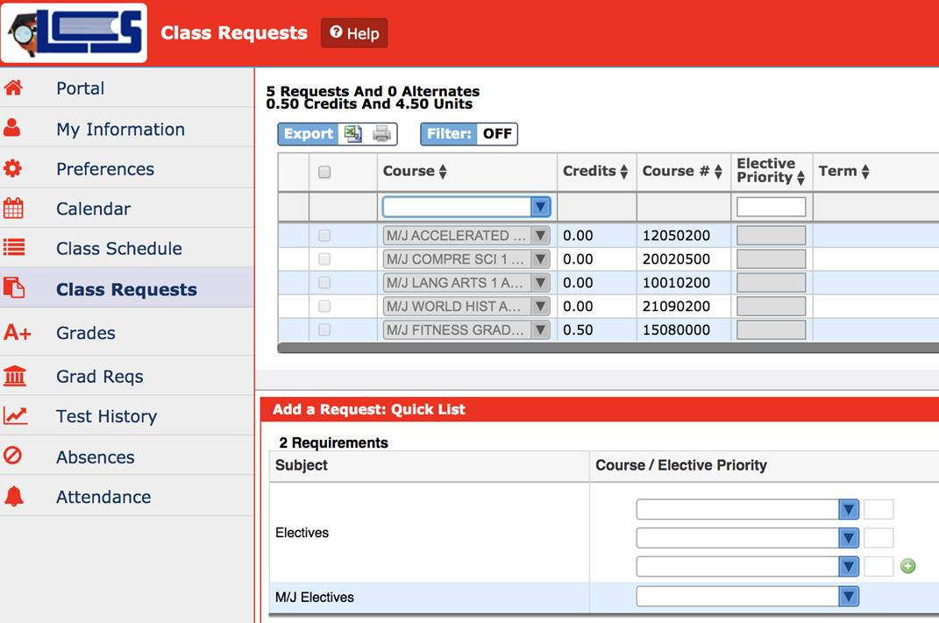

Step 6: Review the core course recommendations. Teacher recommendations cannot be edited. Some students are required to take Learning Strategies as listed on their IEP. This class cannot be changed and will count as one of the student’s electives.

Any student or parent who has a question about the Core Course Recommendation should first consult the Course Recommendation Guide. Questions should then be emailed to the teacher making the course recommendation (i.e., your student’s current teacher) and cc Mrs. Van Camp, the Raa Assistant Principal for Curriculum. The recommendation will be explained and any necessary further steps will be completed at that time.

**Special Note for Advanced Art Courses:**Raa Middle School advanced arts courses require teacher approval for students to be enrolled for the arts elective and an audition. Interested students will select the course on their Elective Request form. *This does not guarantee enrollment in this course for the 2022-2023 school year.*Arts teachers will then approve student elective requests and communicate the approval or denial to students and parents. Information about auditions will be provided by the teacher. See Arts Course Descriptions to determine appropriate elective choice.